Integrated CNT Sensors in Polymer Microchannel for
Gas-Flow Shear-Stress Measurement
Winnie W. Y. Chow¹, Wen J. Li^{1,*}, and Steve C. H. Tung²
¹Centre for Micro and Nano Systems, The Chinese University of Hong Kong, Hong Kong SAR, China
² Department of Mechanical Engineering, University of Arkansas, United States

Abstract — We have developed CNT sensors for gas-flow shear stress measurement inside a Polymethylmethacrylate (PMMA) microchannel. An array of sensors is fabricated by using dielectrophoretic (DEP) technique to manipulate bundled single-walled carbon nanotubes (SWNTs) across the gold microelectrodes on a PMMA substrate. The sensors are then integrated in a PMMA microchannel, which is fabricated by SU-8 molding/hot-embossing technique. Since the sensors detect gas-flow by thermal transfer principle, we have first examined the I-V characteristics of the sensors and confirmed that self-heating effect occurs when the input voltage is above ~1V. We then performed the flow sensing experiment on the sensors using constant temperature (CT) configuration. The voltage output of the sensors increases with the increasing flow rate in the microchannel. We also found that the power of the sensors has a linear relation with 1/3 power of the shear stress. Moreover, measurements of sensors with different overheat ratios were compared and results showed that sensor is more sensitive to the flow with a higher overheat ratio.

Keywords —carbon nanotubes, CNT sensors, flow sensor, shear-stress sensor

Introduction
The study of wall shear stress has been investigated for decades in fluid mechanics particularly in turbulent flow [1]-[3]. Different methods for the measurement of wall shear stress such as Pitot tubes [4] and hot-film [5] have been developed. Among all types of measurement, hot-wire [6] sensors have been widely used because they have minimum disturbance to the flow. The size of the sensors has been shrunk down to improve the resolution. However, for conventional hot-wire sensors, their complex fabrication technique does not only limit the size of the sensors, but also makes mass production difficult. With the use of MEMS technology, the size of the sensors is greatly reduced with uniform geometry and performance. Miniature polysilicon shear stress sensor was successfully built by Ho’s group in UCLA [7]. However, the size of the polysilicon sensor is still in hundred microns range, which may not be suitable for some applications that require smaller size sensor. In addition, their power dissipation (in the range of mW) is relatively high, i.e., the heat generation from the sensors may affect the minute fluidic motion through thermal convection, crippling their abilities to sense the true fluidic flow parameters.
*Contacting Author: Wen J. Li (wen@mae.cuhk.edu.hk)
This project is funded by Hong Kong Research Grant Council (Project Code: 413906) and Hong Kong Innovation and Technology Council (ITS/027/06).

In this paper, we will present our latest development of integrating CNT micro sensor array with a PMMA microfluidic system to sense wall shear stress inside a microchannel. CNT bundles were manipulated by DEP technique across the Au microelectrodes with a gap of ~5μm. Furthermore, the entire microfluidic system was made of polymer, which is bio-compatible and low cost. The fabrication process was also in low temperature compared with the fabrication process of polysilicon devices. CNT sensors have also been proved by our group that they are capable to operate in low power range (~μW) [8], which can minimize the thermal disturbance to the fluid motion. We will first present the operating principle and fabrication process of the CNT sensors. Then, I-V characteristics of the sensors will be studied. The experimental setup of the flow sensing experiment will also be described. Experimental results showed that CNT sensors responded to the air flow in the microchannel. Finally, we will further investigate the sensitivity of the sensors by using different overheat ratios.

Operating Principle of the CNT Sensor
The sensor detects the wall shear stress by using heat transfer principle. The sensor is fabricated at the wall of the microchannel, which is within the velocity boundary layer. The relationship between the shear stress and the velocity is given by (1).
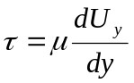 (1)

where µ is the viscosity of the fluid and U_{y} is the flow velocity at a distance y from the wall.
The sensor is heated up to the operating temperature during the flow sensing experiment. The amount of heat loss from the sensor to the flow depends on the flow velocity. Since the sensor is operated in constant temperature (CT) configuration, when the sensor loses heat to the surrounding flow, its resistance increases, then a current is driven to the sensor to keep the sensor resistance constant. The input power is proposed to relate to the shear stress by (2) [7].
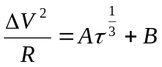 (2)

where A is a fluid related constant and B is the amount of conductive heat loss from the sensor to the substrate.

Fabrication Process of the Integrated CNT Sensor Chip
The fabrication process of the CNT flow sensor chip and the microchannel is illustrated in Fig. 1. Polymethylmethacrylate (PMMA) was used as the device material because it is optically transparent, bio-compatible, and low-cost. A layer of Parylene C (~0.5μm) was first deposited on the PMMA substrate to protect the PMMA substrate and improve the adhesion of gold (Au) to the substrate. Then, an array (19 in total) of Au microelectrodes were fabricated on the substrate by sputtering and photolithography process. The gap distance between each pair of microelectrode is about 2-5μm. Commercial SWNT bundles (Shenzhen Nanotech Port Co. Ltd.) were then batch fabricated across the microelectrode array using dielectrophoretic (DEP) manipulation technique [9].
The microchannel with width 4mm, length 7mm, and height 300μm was fabricated by a customized SU-8 molding/hot-embossing process. A metal mould was first fabricated by using high-aspect ratio lithography, electroplating, and photoresist stripping. A layer of Au (~7000Å) was deposited on a PMMA substrate which served as a seed layer for the electroplating process. Then, a layer (~300μm) of SU-8 was deposited and patterned on the Au layer by photolithography process. The height of the microchannel was defined by this SU-8 layer. After that, Nickel (Ni) was electroplated on the substrate. Nickel was chosen as the mould material because it is much harder than PMMA (Young’s Modulus of Ni = 200GPa). Then, the Ni mould was released from the substrate by photoresist stripping. The microchannel pattern was replicated from the Ni mould to another PMMA substrate by hot-embossing process [10]. Finally, the embossed PMMA substrate was bonded to the PMMA substrate embedded with the CNT sensor array to form a closed microchannel by UV-epoxy. A prototype CNT flow sensor chip is shown in Fig. 2.

Experimental Results
- Flow Sensing Experiment
The schematic of the experimental set-up is shown in Fig. 3. Air flow in the microchannel was supplied by an air compressor. The pressure difference between the inlet and outlet of the microchannel was monitored. The volumetric flow rate was controlled by different inlet-outlet pressure gradients and calculated from the Hagen-Poiseuille equation [11], which is in the order of 10⁻⁵m³/s. The volumetric flow rate of the experiment ranges from 2×10⁻⁵m³/s to 1×10⁻⁴m³/s and the flow inside the microchannel is laminar. During the experiment, a sensor was biased at a current to achieve a known overheat ratio, which was calculated based on the corresponding I-V curve of the sensor from (3). Keithley 2400 source meter was used to study the response of the sensor in constant temperature (CT) mode. By varying the inlet pressure, the corresponding voltage output of the sensor from the CT mode circuit was investigated.

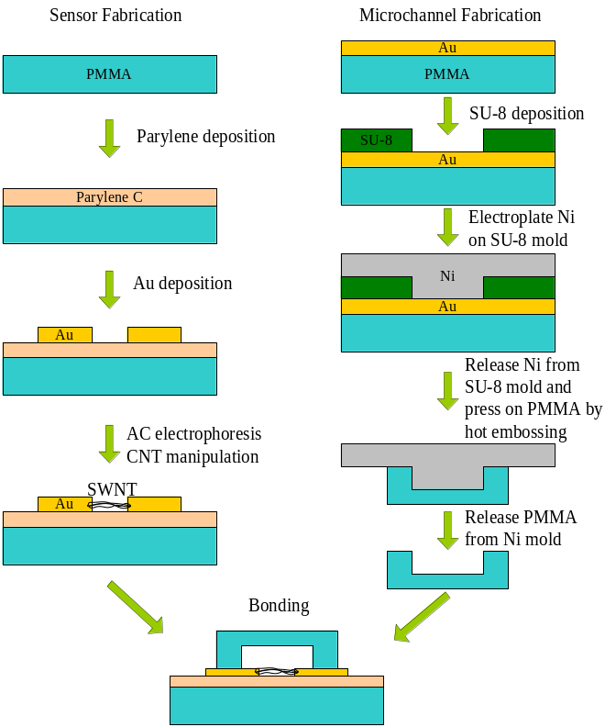
Figure 1. Fabrication process for the CNT based flow sensor inside a PMMA microchannel.

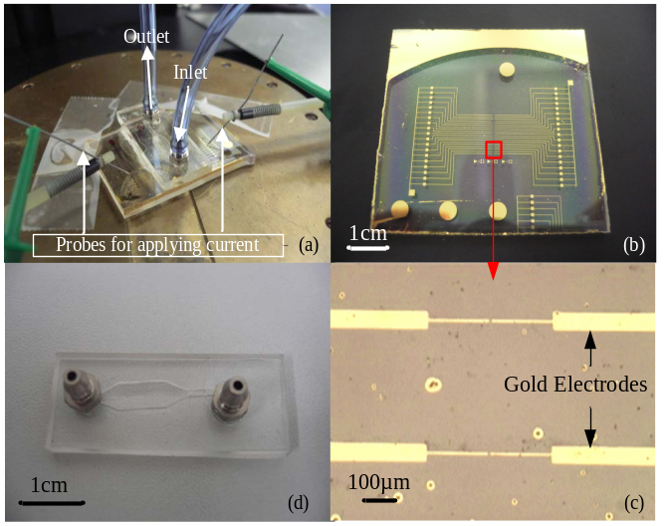
Figure 2. (a) Photograph of the experimental setup of the integrated CNT flow sensor chip. (b) photograph of a CNT flow sensor chip. (c) optical microscope image showing two pairs of microelectrodes. (d) photograph of an embossed PMMA microchannel.
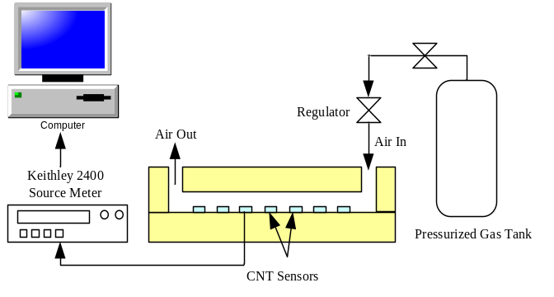
Figure 3. Schematic diagram of the experimental setup of the flow sensing measurement experiment.
- IV Characteristics
Since the flow measurement of the sensor is based on thermal transfer principle, it is important to characterize the sensor by studying its heat transfer and examining its IV characteristics. The IV characteristics of one sensor are shown in Fig. 4. Two measurements were made on the same sensor and were compared with the Ohm’s Law expectation. The results show that the sensor responded non-linearly with the input voltage above ~1V. This indicates that self-heating effect occurred at the operation power range at the order of μW. We can further calculate the resistance overheat ratio α_{R} based on the results shown in Fig. 4 using (3).
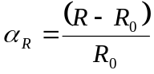 (3)

where R₀ is the resistance of the CNT at the linear region of the IV curve. R is the resistance of the CNT at a given voltage.
Self-heating effect is important in the flow measuring experiment as it ensures the sensor is heated up to its operating temperature. Therefore, overheat ratio is an important parameter in the flow measuring experiment. By varying the input current, we can do the experiment with different overheat ratios and study the sensitivity of the response of the sensor towards the air flow.
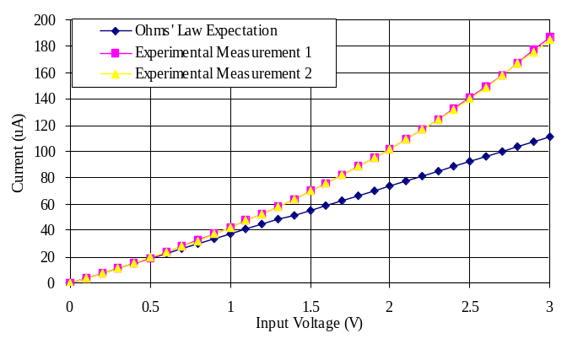
R₀~27kOhm
Figure 4. I-V characteristics of the SWNT sensor inside the microchannel.
- Sensor Response
The response of a sensor towards the air flow is shown in Fig. 5. The sensor was at position 13 in the sensor array, which was about 4mm downstream from the microchannel inlet. Three cycles of measurement were conducted on the same sensor with an overheat ratio ~ -0.12 and similar results were obtained. The change of voltage output increases sharply when the volumetric flow rate is below 5×10⁻⁵m³/s and further increases gradually when the volumetric flow rate is above 5×10⁻⁵m³/s. These results show that more heat is transferred from the sensor to the air flow when the air flow rate is increasing.
We also investigated the sensor response to the shear stress. The power P = (ΔV)²/R is plotted as a function of 1/3 power of the shear stress (τ^{1/3}) in Fig. 6. The power increases linearly with τ^{1/3}, which confirms the relation in (2). From these results, the sensing ability of CNT to gas-flow shear stress measurement is proved.
- Measurements with Different Overheat Ratios
Two measurements were conducted on the same sensor with different overheat ratios to study the sensitivity of the CNT sensors. The results are shown in Fig. 7 and Fig. 8. The tested overheat ratios are -0.09 and -0.13 respectively. As expected, the response of the sensor towards the air flow is greater with a higher overheat ratio. The slopes of the curves are very similar, with a shift of voltage output of about 0.02V. Furthermore, same as the results in the previous measurements, the power increases linearly with the 1/3 power of shear stress with both overheat ratios (for τ^{1/3} > 2.35 Pa^{1/3} when α_{R} = -0.09; for τ^{1/3} > 2.2 Pa^{1/3} when α_{R} = -0.13).
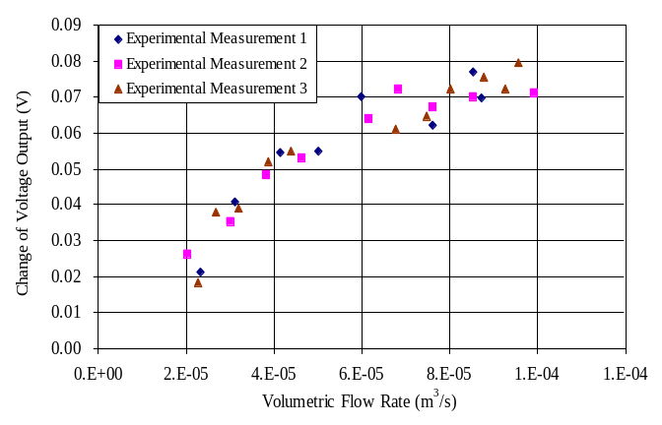
Resistance overheat ratio ~ -0.12
R₀~25.7kOhm
Figure 5. Output voltage variations with different air flow rate.

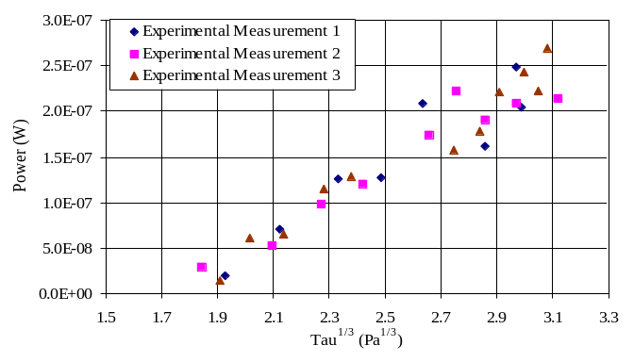
Resistance overheat ratio ~ -0.12
R₀~25.7kOhm
Figure 6. Power (ΔV²/R) variations with 1/3 power of shear stress (τ^{1/3}).
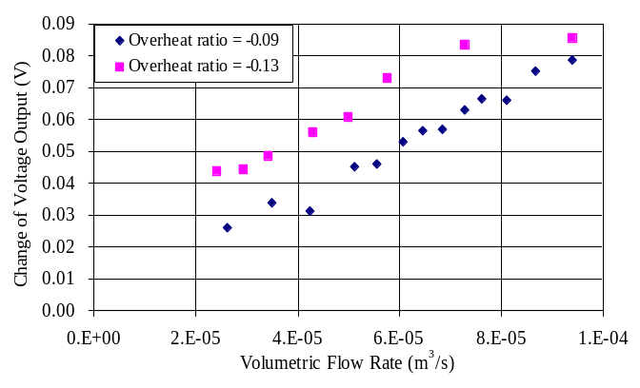
R₀~21.9kOhm
Figure 7. Output voltage variations with different air flow rate for two different overheat ratios.
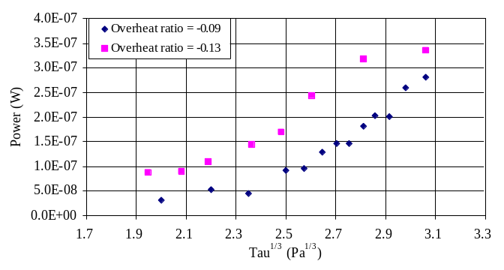
R₀~21.9kOhm
Figure 8. Power (ΔV²/R) variations with 1/3 power of shear stress (τ^{1/3}) for two different overheat ratios.

Conclusion
We have demonstrated CNT sensors for gas-flow shear stress measurement inside a PMMA microchannel. Both CNT sensors and PMMA microchannel were integrated on a single chip so that calibration of the sensors can be performed in a fast and efficient way. IV Characteristics of the sensor indicated that the sensor can be heated to the operating temperature. Experimental results showed that sensor responded to the air flow in the microchannel and the power ΔV²/R was found to be linearly related to 1/3 power of the shear stress. Flow sensing experiments with different overheat ratios were performed, which showed that the sensitivity of the sensors can be adjusted by the overheat ratio. The sensor array can be further developed to study the flow profile at different positions in the microchannel by recording several sensors data simultaneously for the future work.
Acknowledgment
The authors would like to sincerely thank Dr. Y. W. Cheung for providing technical support for the fabrication processes and Dr. K. F. Lei and Dr. K. M. Fung, for their help in this project.

References
- M. R. Head and P. Bandyopadhyay, “New aspects of turbulent boundary-layer structure”, Journal of Fluid Mechanics, 107, pp.297-338, 1981.
- P. H. Alfredsson, A. V. Johansson, J. H. Haritonidis, and H. Eckelmann, “The fluctuating wall-shear stress and the velocity field in the viscous sublayer”, Physics of Fluids, 31, pp.1026-1033, 1988.
- M. Kimura, S. Tung, J. Lew, C-M. Ho, F. Jiang, and Y-C Tai, “Measurements of wall shear stress of a turbulent boundary layer using a micro-shear-stress imaging chip”, Fluid Dynamics Research, 24, pp.329-342, 1999.
- J. H. Preston, “The determination of turbulent skin friction by means of Pitot tubes”, Journal of the Royal Aeronautical Society, vol. 58, pp.109-121, 1953.
- T. Yoshino, Y. Suzuki, N. Kasagi, and S. Kamiunten, “Optimum design of microthermal flow sensor and its evaluation in wall shear stress measurement”, Proc. IEEE MEMS 2003, pp.193-196, 2003.
- S. Haasl, D. Mucha, V. Chernoray, T. Ebefors, P. Enoksson, L. Lofdahl, and G. Stemme, “Hybrid-mounted micromachined aluminum hotwires for wall shear-stress measurements”, Journal of Microelectromechanical Systems, vol. 14, no. 2, pp.254-260, 2005.
- C. Liu, J-B Huang, Z. Zhu, F. Jiang, S. Tung, Y-C Tai, and C-M Ho, “A micromachined flow shear-stress sensor based on thermal transfer principles”, Journal of Microelectromechanical Systems, vol. 9, no. 1, pp.90-99, 1999.
- C. K. M. Fung, M. L. Y. Sin, T. K. F. Lei, W. W. Y. Chow, K. W. C. Lai, and W. J. Li, “Flow rate measurement inside polymer microfluidic systems using carbon nanotube sensors”, Proc. IEEE Sensors 2005, pp.541-544, 2005.
- V. T. S. Wong and W. J. Li, “Bulk carbon nanotubes as sensing element for temperature and anemometry micro sensing”, Proc. IEEE MEMS 2003, pp.41-44, 2003.
- K. F. Lei, W. J. Li, and Y. Yam, “Effects of contact-stress on hot-embossed PMMA microchannel wall profile”, High Aspect Ratio Micro-Structure Technology Workshop (HARMST), 2003.
- M. Koch, A. Evans, and A. Brunnschweiler, Microfluidic technology and applications, Research Studies Press Ltd., pp.3-16, 2000.

