Towards Batch Fabrication of Bundled Carbon Nanotube Thermal Sensors
Carmen K. M. Fung, Victor T. S. Wong, and Wen J. Li*
Centre for Micro and Nano Systems
The Chinese University of Hong Kong
Hong Kong SAR
*wen@acae.cuhk.edu.hk

Abstract—A new approach for batch fabrication of carbon nanotubes (CNT) based MEMS thermal sensor was developed using AC electrophoretic manipulation of MWNT bundles on a silicon substrate. Based on this technique, CNT were successfully and repeatably manipulated by AC electrophoresis to form resistive elements between Au microelectrodes. We have preliminarily proved the feasibility to batch assembly of CNT devices with greater than 70% success rate. Besides, the devices were demonstrated to potentially serve as novel thermal sensors. We have measured the temperature coefficient of resistance (TCR) of these MWNT-based micro sensors and also integrated them into constant current configuration for dynamic characterization. The I-V measurements of the resulting devices revealed that their power consumption were in the μW range. Based on these experimental evidences and our proposed new approach, a feasible batch manufacturable scheme for functional CNT based thermal sensors is suggested which will dramatically reduce production costs of nano sensing devices and potentially enable fully automated assembly of CNT-based devices.
Keywords-carbon nanotube; nano sensor; thermal sensor; nano manufacturing; nano batch-fabrication

INTRODUCTION
Carbon nanotubes (CNT), since discovered in 1991 by Sumio Iijima [1], have been extensively studied for their electrical (e.g., see [2]) and mechanical properties (e.g., see [3]). In order to build a CNT based device, technique to manipulate the CNT has to be developed. However, CNTs tend to cling together in nature due to the presence of strong surface charges on their surfaces. The difficulty of isolating a single CNT from an intertwined bundle without tremendous effort (in the sense of batch fabrication) has led to a clear boundary between the two approaches of the usage of CNTs: either to treat each CNT as an individual building element, or to treat CNT bundles (or array) as a whole building block.
To fabricate a nanodevice with CNTs/nanowire as individual building elements, the basic requirements include the isolation, manipulation, transport, fixture and connection, etc., of a single CNT. By means of AFM-based assembly method, a variety of mechanical and electronic nanodevices have been fabricated by researchers. However, few efforts have been reported to tackle the fundamental problem of the inefficiency caused by AFM operations when the process turns into batch production. As a result, most reported nanodevices are either proofs of principle or just prototypes. Among which, Kim et al., have reported a method to align CNTs side by side by means of condensation of nanowire solution [4][5]. On the other hand, bypassing the complex AFM operations completely, some of the nanodevice researchers have shifted to focus on treating CNT/nanowire bundles as an individual functional (e.g., sensing) element. By means of chemical vapor deposition (CVD), in combination with lithography techniques [6] or laser trimming [7], “vertically” aligned CNT/nanowires can be grown and patterned on specific sites in batch mode. The nanodevices developed based on this approach generally treat a bundle of aligned CNT/nanowires as one functional (i.e., sensing, emitting, etc.) element. By patterning an array of “functional bundle”, a functional array is formed. Moreover, electric-field assist assembly is another feasible technology in batch fabrication of CNT/nanowires devices. K. Yamamoto et al., has pioneered the work in electric-field assembly of CNT bundles [8][9]. The usage of electric-field assist assembly has also been reported for batch assembly of nanowires as well [10]. By using similar technique (i.e., AC electrophoresis), we have successfully manipulated bundled carbon nanotubes to form resistive elements between Au microelectrodes for thermal sensing efficiently. This paper reports the technique to form bundled MWNT resistive element between Au electrodes and our experimental findings on the I-V characteristics of the bundled MWNT sensors. The feasibility to batch fabricate these CNT thermal sensors is also presented.
* Wen J. Li is an associate professor at the Chinese University of Hong Kong and is also serving as an affiliated professor at the Shenyang Institute of Automation. This project is funded by the Hong Kong Research Grants Council (CUHK4206/00E and 4381/02E), the Chinese Academy of Sciences’ Distinguished Overseas Scholar Grant, and the Chinese National 863 Plan (Project Ref. No.: 2002AA431620).

EXPERIMENTAL RESULTS
We have successfully developed the technique of CNT formation by using the AC electrophoresis process and also investigated the feasibility of using this technology to mass-manufacturing of CNT devices, i.e., the yield and the consistency of the batch fabrication process. The detailed procedure and results of the experiments will be presented in this section.

Formation of CNT elements by AC electrophoresis

Theoretical Background
AC electrophoresis (or dielectrophoresis) is a phenomenon where neutral particles undergoing mechanical motion inside a non-uniform AC electric field (see Figure 1). Detailed descriptions on AC electrophoresis can be found in [11]. The dielectrophoretic force imparted on the particles can be described by the following equation:
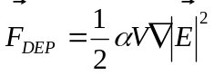 (1)
where is the polarizability of the particles, which is a frequency dependent term. V is the volume of the particles and =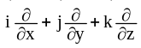is the gradient operator.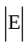 is the magnitude of the electric field strength. Equation (1) reveals that the generated force is dependent of the gradient of electric field rather than the direction of electric field. Besides, the polarizability function also determines whether the force generated is attractive (positive dielectrophoresis) or repulsive (negative dielectrophoresis).
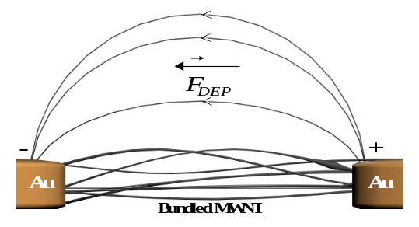
Figure 1. Under non-uniform AC electric field, dielectrophoretic force induced on the neutral particles cause mechanical motion on the particles.

Experimental Details and Results
The bundled MWNT used in the experiments were ordered commercially from [12] (prepared by chemical vapour deposition). The axial dimension and the diameter of the MWNT was 1 – 10 μm and 10 – 30 nm, respectively. Prior to the MWNT manipulation, 50 mg of the sample was ultrasonically dispersed in 500 mL ethanol solution and the resulting solution was diluted to 0.01 mg/mL for later usage.
The process for the experiment is shown in Figure 3. In this work, arrays of Au microelectrodes were fabricated and connected together (totally 14 sensor-microelectrodes) on the substrate. After that, the silicon substrate with arrays of sensor-electrodes was place on the vacuum-pump stage of a micromanipulator station. Then approximately 10 μL of the MWNT/ethanol solution was transferred to the substrate by 6 mL gas syringe and the Au microelectrodes were excited by AC voltage source (typically, 16 V peak-to-peak at 1 MHz). The ethanol was evaporated away leaving the MWNT to reside between the gaps of the microelectrodes. To test the connectivity of MWNT to the electrodes for each sensor, room temperature resistances between the microelectrodes were measured before the sensors were advanced to the next fabrication procedure. In order to investigate the success rate of CNT connection of each sensor, we have performed repeatable experiments on different samples with arrays of fabricated microelectrodes.
Figure 2. Scanning electron microscopic (SEM) image showing the MWNT connections between Au microelectrodes.
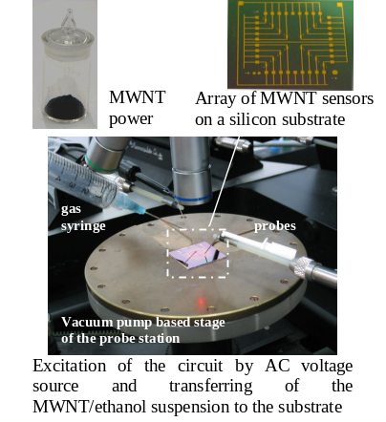
Figure 3. Current experimental setup for CNT manipulation to build MWNT sensors.
We experimentally found that the resistances of the MWNT bundles were sample dependent (i.e., different MWNT samples have different room temperature resistances) and the two probe room temperature resistances of the samples typically range from several kΩ to several hundred kΩ. Since the conductivity of CNTs depend on their lattice geometries during their growth process, the conductivities of individual CNT cannot be well controlled, which results in the variation of conductivities in individual CNT. During the AC electrophoresis process to form MWNT bundles across microelectrodes, the MWNT was randomly connected between microelectrodes. Therefore, it is logical that different MWNT samples exhibited different conductivities.
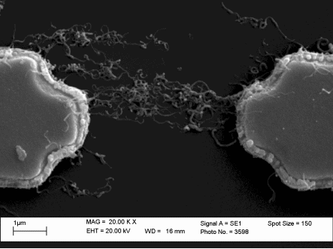
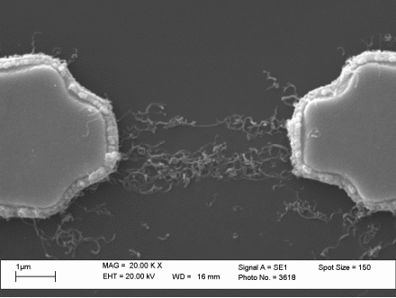
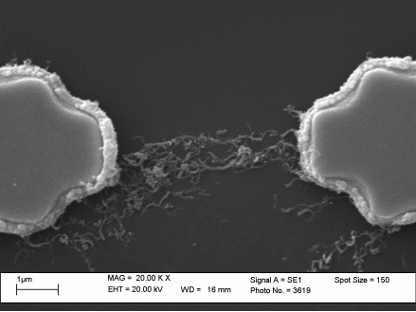
The connection of the bulk CNT of different sensors on one substrate sample is shown in Figure 2. After recording the resistance of all sensors on different samples, a plot of statistical data on the resistance measured was generated and is shown in Figure 4, which shows the maximum, minimum, average and standard deviation (S. D.) among the measured resistances on each sample. We have also proved that the overall success rate for the CNT manipulation on different samples after one drop of the CNT solution is greater than 70%, which is currently considered as an exceptional yield for nanodevices manufacturing. In a latter section, we will describe our proposed new approach for the batch fabrication to improve our technique to possibly obtain a 100% yield.
64.6KΩ
280KΩ
264ΚΩ
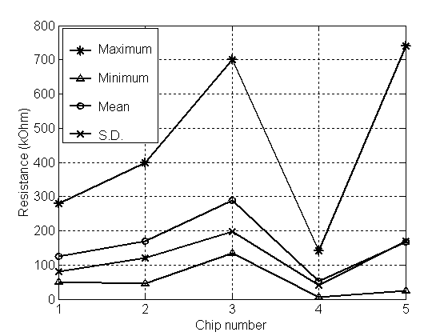
Figure 4. Plots of statistical data of measured resistances between the Au-electodes on differnet samples.

CNT thermal sensor
From our pervious demonstration in [13], we have successfully proved that CNT is promising to be used as high performance and low power consumption devices for thermal sensing. In order to investigate the thermal sensing property of the CNT device, the sensors were placed in an oven and the corresponding resistance changes with the specific temperature were monitored. The TCR was obtained from the experimental measurements (See Figure 5). We observed that the resistance of the bundled CNT devices dropped with temperature, which is in agreement with [13] (i.e., negative TCR).
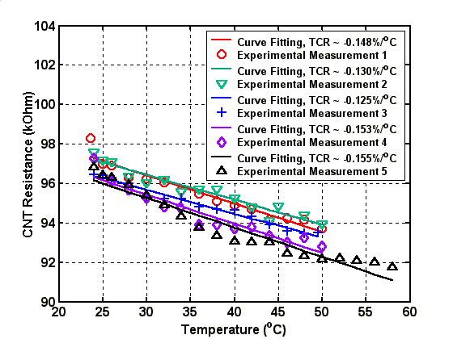
Figure 5. TCR for a typical bundled MWNT device in five different measurements.
The ranges of TCR measurements of all of our testing devices were generally within -0.1 to -0.2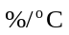. Therefore, the temperature-resistance dependency of bundled MWNT implied its thermal sensing capability. Besides, from the I-V measurement of the bulk MWNT device, the current required to induce the self heating of the device was in 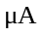range at several volts, which suggested the power consumption of the device was in 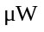range (See Figure 6).
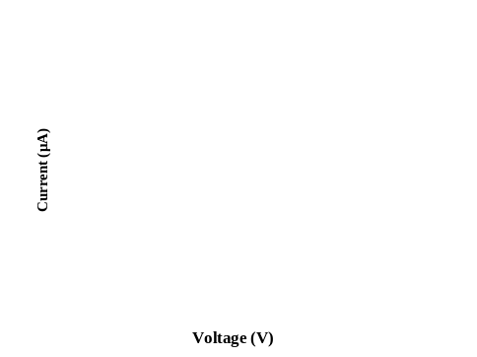
Figure 6. I-V characteristics of a typical bundled MWNT device. Three repeated measurements were performed to validate its repeatability. The straight line is the theoretical expectation using Ohm’s Law and the room temperature resistance of bundled MWNT in our testing sample was about 170kΩ.

PROPOSED BATCH FABRICATION OF CNT THERMAL SENSORS
Based on the results of CNT formation by using AC electrophoresis process and the thermal sensing capability of the bundled CNT devices, a nano-robotic-injection system is under development to batch fabricate CNT thermal sensors. In this section, the methodology and procedure of the nano-robotic based batch fabrication of CNT sensing arrays will be presented.
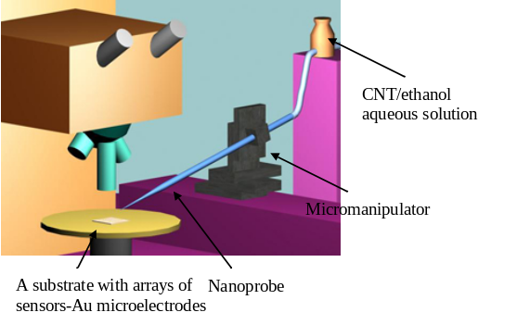
Figure 7. Conceptual illustration of the nano-robotic-injection system to be built for this project.
The batch fabrication of CNT based thermal sensing arrays can be implemented by a three-dimensional nano-robotic injection and transferring system. It includes three major components: a nano-positioning stage, a computer-controllable micromanipulator of a micromanipulator station and a KL probe (See Figure 7). The process for the batch fabrication can be divided into two different parts: sample preparation and CNT manipulation.
After the CNT/ethanol solution is prepared as described in the pervious section, it will be injected on to a sensor chip using a KL probe (See Figure 7). The KL probes can be fabricated with inner diameter of around 5μm as descried in [15][16]. When batch-fabricating the CNT sensors, the KL probe will be used to transfer the CNT/ethanol solution to the substrate. The probe will be attached to a three-dimensional computer controllable micromanipulator, which is used to control the x-y-z movement of the probe. In order to control the nanoprobe accurately and provide a computer-based and automated injection and transferring system, a Sutter Instrument Company MP-285 Motorized Micromanipulator will be used in the experiment. The three-axis robotic movement will be controlled by the programmable computer controller and software interface developed by the company and improved by our team. By using this micromanipulator-probe injection system for batch CNT manipulation, we will develop a fully automated nano-injection system to align the KL probe to the desired electrode positions on a substrate. A nano-positioning stage can also be used to move the substrate to fine-tune the final position of droplet deposition. After a droplet of CNT/ethanol solution is placed between two electrodes, dielectrophoretic nano-manipulation will be applied to form the CNT sensing elements between the electrodes as described below.
After developing the arrays of sensors-Au microelectrodes, the sensor chip (substrate) is placed on the vacuum-pump stage of a micromanipulator station. Then, the KL probe is commanded to move to one set of the microelectrodes, and a droplet of the CNT/ethanol solution is transferred to the sensor electrodes by the KL probe. Immediately after this, the Au microelectrodes are excited by an AC voltage source (See Figure 8). After that, the KL probe is commanded to move to the position of another sensor, and the entire process repeats again. By using the computer controllable nano-robotic system and the technique of CNT formation, a fast and accurate system for the batch fabrication of CNT-based thermal sensors will be provided.

CONCLUSION
A technique to form bundled MWNT resistive elements between Au electrodes was presented. The TCR measurements of the bundled MWNT based MEMS sensors showed that bundled MWNT can be used as a sensing element for high performance, i.e., ultra-low-power thermal sensing applications. Also, by introducing the proposed nano-injection robotic-based batch fabrication system, we will improve our technique to possibly obtain a 100% yield of batch assembly of CNT bundled nanodevices in the future.

Acknowledgment
The authors would like to sincerely thank Dr. W.Y. Cheung of the Department of Electronic Engineering of CUHK, Ms. Catherine Yeung of Department of Physics of CUHK, and Mr. King W. C. Lai, Mr. H. Y. Chan, Mr. Gordon M. H. Chan and Ms. Jennifer W. L. Zhou of Centre for Micro and Nano Systems of CUHK for their help and discussion on this project.

References
- S. Iijima, “Helical Microtubules of Graphitic Carbon”, Nature, Vol. 354, 1991, pp. 56 – 58.
- S. Frank, P. Poncharal, Z.L. Wang, W.A. de Heer, “Carbon Nanotube Quantum Resistors”, Science, Vol. 280, 1998, pp. 1744 – 1746.
- E.W. Wong, P.E. Sheehan, C.M. Lieber, “Nanobeam Mechanics: Elasticity, Strength, and Toughness of Nanorods and Nanotubes”, Science, Vol. 277,1997, pp.1971 – 1975.
- F. Kim, S. Kwan, J. Akana, P. Yang, “Langmuir-Blodgett Nanorod Assembly”, Journal of American Chemical Society, Vol. 123, No. 18, 2001, pp. 4360 – 4361.
- D. Appell, “Wired for Success”, Nature, Vol. 419, 2002, pp. 553 – 555.
- B.Q. Wei, R. Vajtai, Y. Jung, J. Ward, R. Zhang, G. Ramanath, P.M. Ajayan, “Organized Assembly of Carbon Nanotubes”, Nature, Vol. 416, 2002, pp. 495 – 496.
- F.C. Cheong, K.Y. Lim, C.H. Sow, J. Lin, C.K. Ong, “Large Area Patterned Arrays of Aligned Carbon Nanotube via Laser Trimming”, Nanotechnology, Vol .14, 2003, pp. 433 – 437.
- K. Yamamoto, S. Akita, Y. Nakayama, “Orientation of Carbon Nanotubes Using Electrophoresis”, Japanese Journal of Applied Physics, Vol .35, 1996, pp. L917 – 918.
- K. Yamamoto, S. Akita, Y. Nakayama, “Orientation and Purification of Carbon Nanotubes Using AC Electrophoresis”, Journal of Physics D: Applied Physics, Vol. 31, 1998, pp. L34 – L36.
- P.A. Smith, C.D. Nordquist, T.N. Jackson, T.S. Mayer, B.R. Martin, J. Mbindyo, T.E. Mallouk, “Electric-field Assisted Assembly and Alignment of Metallic Nanowires”, Applied Physics Letters, Vol. 77, No. 9, 2000, pp. 1399 – 1401.
- H.A. Pohl, “Dielectrophoresis: The Behaviour of Neutral Matter in Nonuniform Electric Fields”, Cambridge University Press, 1978.
- Sun Nanotech Co Ltd, Beijing, P.R. China.
- V.T.S. Wong, W.J. Li, “Bulk Carbon Nanotubes as Sensing Element for Temperature and Anemometry Micro Sensing”, Proc. of 16th IEEE International Conference on Micro Electro Mechanical Systems 2003, pp. 41 – 44.
- T.W. Ebbesen, H.J. Lezec, H. Hiura, J.W. Bennett, H.F. Ghaemi, T. Thio, “Electrical Conductivity of Individual Carbon Nanotubes”, Nature, Vol. 382, 1996, pp. 54 – 56.
- C. C. H. Kwong, K. W. C. Lai, and W. J. Li, "Kwong-Li Probes: Novel Nano-Probes for Biological Dissection and Injection", invited paper, IEEE/ASME International Conference on Advanced Intelligent Mechatronics, Kobe, Japan, 2003.
- K.W.C. Lai, C. C. H. Kwong, and W.J. Li, “KL Probes for Robotic-Based Cellular Nano Surgery”, invited paper, Third IEEE Conference on Nanotechnology 2003, San Franscisco, USA, August 2003.

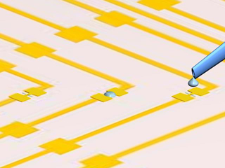
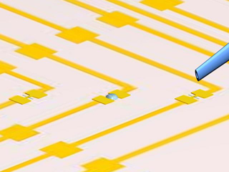
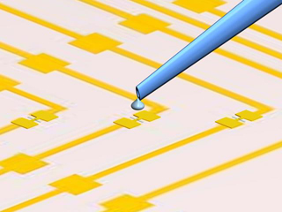
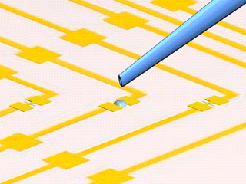
(a)
(b)
(c)
(d)
Figure 8. (a) The KL probe is positioned by the nano-robotic-injection system to the proximity of two Au electrodes and begins to eject the CNT/ethanol solution. (b) and (c) After ejecting a droplet, the probe is moved to the 2nd sensing electrodes. At the same time, AC electrophoretic voltage is applied between the 1st set of electrodes to form the CNT sensing element. (d) The process repeats again for the 2nd sensing electrodes.

