Towards Automated Nanomanipulation of Nano-Bio-Entities using Real-Time Molecular Force Feedback Information

Yongliang Yang^{1, 3}, Zaili Dong¹, and Wen J. Li^{1, 2,*}
¹ State Key Laboratory of Robotics, Shenyang Institute of Automation, Chinese Academy of Sciences, Shenyang, China
² Centre for Micro and Nano Systems, The Chinese University of Hong Kong, Hong Kong, China
³ Graduate University of the Chinese Academy of Sciences, Beijing, China

Abstract - Bovine insulin molecular aggregates, a nano-scale bio-entity, has been manipulated using P-NUVO (Programmable nanomanipulation using vibration-mode operation AFM) method. This method uses the amplitude of an AFM cantilever’s vibration as real-time feedback information to detect the boundary of the nano-entities under manipulation. This amplitude signal changes as a function of the distance between the probe-tip and a nano-entity due to their inter-molecular force interactions. The AFM tip’s manipulating path could also be planned according to the manipulation task. Different configuration of bio-nano-entities, i.e., sphere and rod configurations were manipulated. Due to the difficulties of the sample preparation process, the real-time feedback information did not work as well as for other nano-entities such as carbon nanotubes.

Index Terms - AFM, Automated nanomanipulation, Bio-nano-manipulation, Programmable nanomanipulation, Nano-robotics.

I. Introduction
THe atomic force microscope (AFM) [1] has become a must-have tool for nanoscience and nanotechnology researchers since its invention. It not only can be used to observe the nano-sample’s surface with resolution down to nanometer scale, it is also a powerful tool to manipulate nano-entities with nanometer position accuracy [2]. The AFM based nanomanipulation, possibly initiated by Juno et al., at the university Lund [3], has been studied for more than a decade to improve its efficiency and effectiveness. A haptic device has already been introduced in the nanomanipulation system to control the AFM tip’s path manually [4] [5]. A method based on virtual reality technique, has also been developed to improve the efficiency of AFM based nanomanipulation [4]. Since the AFM tip is used both as the manipulator and detector in existing systems, it is difficult to get feedback information in real-time, i.e., the visual feedback interface is not updated in real-time during the manipulating procedure in almost all existing manipulation techniques. To address this problem, Xi’s group at Michigan State University developed an augmented reality nanomanipulation system, which has real-time force and visual feedback [6]. In their work, the AFM cantilever provides the interaction forces as a sensor through a dynamic model of the AFM cantilever. The visual interface is updated through the dynamical model of the manipulation procedure. However, due to the complication of the nano-world, it is almost impossible to establish an accurate dynamic model. We developed a manipulation method using vibration-mode operation AFM to address this problem [7] [8]. In this method, the amplitude signal of the cantilever’s vibration could be used as real-time feedback information, i.e., its vibration conditions depends on its proximity to nearby nano-entities. We also note here that a physical model of the process of manipulating nanoparticles has also been studied by Sitti’s group [9] [10]. And, to improve the efficiency and repetitiveness of the nanomanipulation using AFM tip, automated manipulation system has also been investigated. Xi’s group [11] and Requicha’s group [12] have developed their automated nanomanipulation systems separately. Again, due to the complexity of the nano-environment, automatic manipulation of nano-entities is still an elusive goal to achieve for nano-robotic researchers.
We note here another problem with conventional AFM manipulation techniques: since the AFM tip can only exert the pushing force on a point of nano-entities, it is more difficult to manipulate flexible 1-D nano-entities than nanoparticles and nanorod using AFM based nanomanipulation. The P-NUVO (Programmable nanomanipulation using vibration-mode operation AFM) method addressed this problem to some extent by planning the tip’s path properly [8]. We have proved that this method can improve the manipulating efficiency dramatically.
Finally, we should also note that manipulating bio-nano-entities mechanically is very meaningful in terms of scientific research, because the mechanical properties and the geometrical configuration of bio-entities could influence their bio-functions. For example, J. Hu et al., manipulated DNAs to detect its properties and proposed possible applications for DNA manipulations [13]. In addition, in order to test the electrical and mechanical properties of bio-nano-entities for integration into advanced nanodevices, mechanical manipulation of these nano-entities is also very important.
In this paper, we present our on-going work to manipulate a bio-nano-entity, i.e., bovine insulin molecular aggregates, using the P-NUVO method. Section II provides the sample preparation method and a brief description of P-NUVO method. The experimental results and discussion are presented in section III. Our future work is discussed in section IV.
II. Material and P-nuvo Method
The bovine insulin is composed of two peptide chains, a chain structure with 21 amino acids and a  chain with 30 amino acids. The sample used in our experiments was made by Sigma-Aldrich Inc. The bovine insulin powder was dissolved in DI water with 1µg/µl Na₂SO₄ and the density of the resulting bovine insulin was 1 mM. HCl was used regulate the PH of the solution to 5.35. A 2µl volume of this mixed bovine insulin solution was dropped onto a freshly cleaved mica substrate. After the liquid evaporated, we could observe and manipulate the bovine insulin molecular aggregates using AFM tip. The AFM system used in our experiment is Nanoman II system with Nanoscope IV controller made by Veeco Inc.
The P-NUVO method is based on the vibration-mode operation AFM with control loop engaged. The amplitude of the AFM cantilever’s vibration is kept in different setpoints during imaging and manipulating modes. In the imaging mode, the amplitude setpoint is set to large value, i.e., ~ 1V in our system, thus the AFM cantilever is kept at a relatively large distance from the substrate. In the manipulation mode, the amplitude setpoint is kept at a much lower value, i.e., 0.01 V in our system. In this case, the AFM tip is kept at a small distance from the substrate. This distance is smaller than the height of the nano-entities, so the nano-entities can be manipulated.
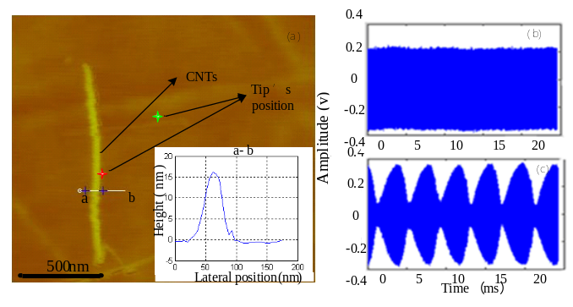Fig. 1. The real-time feedback information used in P-NUVO method. The sample is MWCNTs, and the substrate is polymer (PMMA). (2) and (3) show the amplitude signal vs. time without ( i.e., the green cross position) and with (i.e., the red cross position) CNTs, respectively. Detailed description is offered in [7].
The P-NUVO method has real-time feedback information to verify the manipulation result and a well planed AFM tip’s path according to the manipulation task. The real-time feedback information is the amplitude signal of the AFM cantilever’s vibration, which can be detected using an opto-electronic detector. When the AFM tip locates at the boundary of a nano-entity, its amplitude signal will be in periodical vibration mode; in contrast, when the AFM tip is “far away” from a nano-entity, its amplitude signal is kept stable, as shown in the Fig.1. After the AFM tip finished a pushing task, the AFM tip could locate at the boundary of a nano-entity if the manipulation succeeds, i.e., its amplitude signal will be in periodical vibration mode. But, if the manipulation failed, and the tip is consequently “far away” from the nano-entity, its amplitude signal is kept stable. The period of the amplitude signal’s vibration is about 2 ms. After the manipulation, the amplitude setpoint is set to large one that is suitable for AFM imaging, and the manipulation result can be verified using this signal in several milliseconds. Detailed explanation of this real-time feedback information has been reported in [7].
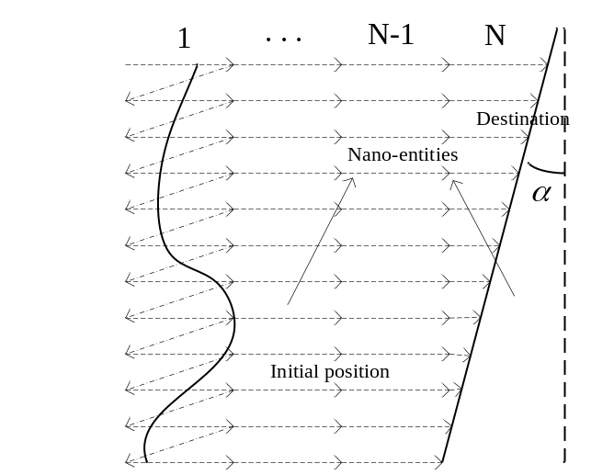
Fig. 2. A sketch of an example of P-NUVO method manipulation strategy. The solid lines denote a 1-D flexible nano-material, and the broken arrowhead lines denote the path and direction of the pushing tip. The left end of the broken arrowhead lines is the start line of AFM tip’s movement, and the arrowhead position is the destination of each push. According to the distance between the start-line and the destination, the manipulation procedure is divided into N parts.
Another advantage of this novel method is that the nanomanipulation system plans the AFM tip’s path to conquer the intrinsic drawback of the AFM system: the AFM tip can only exert the pushing force on one point of the nano-entities. Besides controlling the AFM tip to move along the pushing direction, the AFM tip is also controlled to move in the direction perpendicular to the pushing direction. A sketch of an example of the P-NUVO method is provided in Fig. 2. Thus, 1-D or relative “big” 0-D nano-entity can be manipulated as a whole. Since some bio-nano-entities are quite soft, the AFM tip can easily break them when the manipulation destination is excessively long, as shown in next part of this paper. Hence, the manipulation task should be divided into several parts, so that the total pushing force can be reduced.
The manipulation procedure can be executed automatically using this P-NUVO method in the Nanoman II SPM system. After the user defines the start position and destination of the manipulation task through the user interface software, the manipulation program can execute the task automatically. Detailed information of the P-NUVO method can be obtained in our published papers [7] [8].
III. Experimental Results and Discussion
The shape of bovine insulin molecular aggregates could be a nanorod or a nanoparticle. They were both manipulated by using P-NUVO method in our experiments.
In these experiments, the real-time feedback information did not work well as for manipulating CNTs. The amplitude signal was in periodical vibration mode even when the AFM tip was on the substrate during imaging mode. The reason for this phenomenon is that many residual molecular aggregates are present on the substrate after the insulin solution evaporated; hence, the amplitude signal was in periodical vibration mode when the AFM tip was moved close to these residual molecular masses. Thus, the amplitude vibration signal could not be used as feedback information to verify the manipulation results.
As mentioned earlier, the mechanical properties of these bovine insulin aggregates are different from that of other nano-entities we have manipulated in our prior work e.g., gold nanoparticles and CNTs. This caused many difficulties in implementing the P-NUVO method in manipulating bio-nano-entities. Firstly, some of the bio-nano-entities are soft. For example, the shape of nano- sphere –shaped molecular aggregates was changed after manipulation due to its softness. In Fig. 3, the bio-nano-entity was almost separated into two particles by the pushing force. Secondly, the adhesion force between the bio-nano-entity and the substrate was quite strong. In the experiment data shown in Fig. 3, the AFM tip passed over the object and could not move it because of the strong adhesion force.
The AFM tip’s path plan also had impact on the manipulation results. The pushing length of every step can affects the frictional force between the bio-nano-entities and the substrate. We performed three experiments using the pushing lengths of every step to be 150 nm, 100 nm, and 90 nm. When the length is 150 nm, the AFM tip passed over the bio-nano-entity, and the object was broken by the tip due to the adhesion force being greater than the force to break to bio-nano-entities. When the length was 100 or 90 nm, the bio-nano-entities were manipulated to the destination. Since the bio-nano-entity is soft, so when the AFM tip pushed it, it does not move as a whole, but rather a part of it moves. And, the large the distance the tip moves, it moves along with it a bigger part of the bio-nano-entity being manipulated. But, in nano-world, friction is also directly proportional to the size of contact area [14]. Thus, when the bigger part of bio-nano-entity moves, the friction will also increase accordingly. So, the length of every manipulation step can directly affect the friction between the bio-nano-entities and the substrate.
The rod-shaped bovine insulin molecular aggregates were also manipulated. The experimental results are shown in Fig. 6 (the manipulation experiments also include a particle). The bio-nano-rod acted as a rigid rod. The vertical displacement was quite little, which is different from that of manipulating the sphere-shaped bovine insulin molecular aggregates. An interesting observation was recorded during this experiment – the rod and the particle seem to have some kind of interacting molecular forces between them. That is, the rod and the particle seemed to move as a single entity. . The particle moved along with the rod when the rod-shaped bio-nano-entity was pushed, and conversely, when the particle was pushed, the rod also moved with it. We are currently investigating this phenomenon in much more detail.
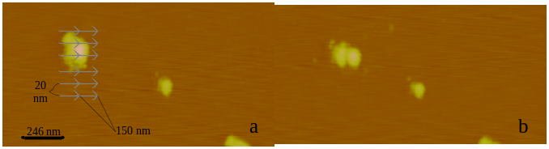Fig. 3. Experimental results of manipulating bovine insulin molecular aggregates. The arrowhead line donates the AFM tip’s path. The height of the bio-nano-entities is about 10 to 15 nm.
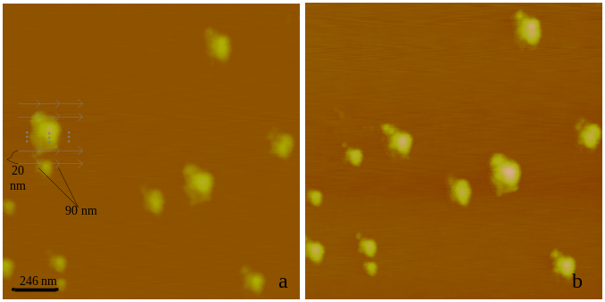Fig. 4. Experimental results of manipulating bovine insulin molecular aggregates. The arrowhead line donates the AFM tip’s path. The height of the bio-nano-entities is about 10 to 15 nm.

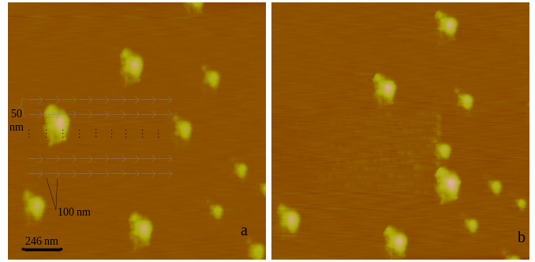Fig. 5. Experimental results of manipulating bovine insulin molecular aggregates. The arrowhead line denotes the AFM tip’s path. The height of the bio-nano-entities is about 10 to 15 nm.

IV. Future Work
The above experiments show that the AFM-based bio-nano-manipulation with real-time feedback information did not work as well as expected and that the mechanical properties of bovine insulin molecular aggregates are related with their geometrical shape. For example, the sphere-shaped molecular aggregate, with 15 nm height, is soft; the rod-shaped molecular aggregate, with 70 nm height, is rigid. The experimental results also show that the pushing length of every manipulation step can affect the frictional force between the bio-nano-entities and substrate.
To achieve the automated nanomanipulation of bio-nano-entities, a new real-time feedback should be developed. And, the AFM path plan will play a key role in achieving successful bio-nano-manipulation results. Moreover, quantitative analysis of the variables of the path plan should be carried out.
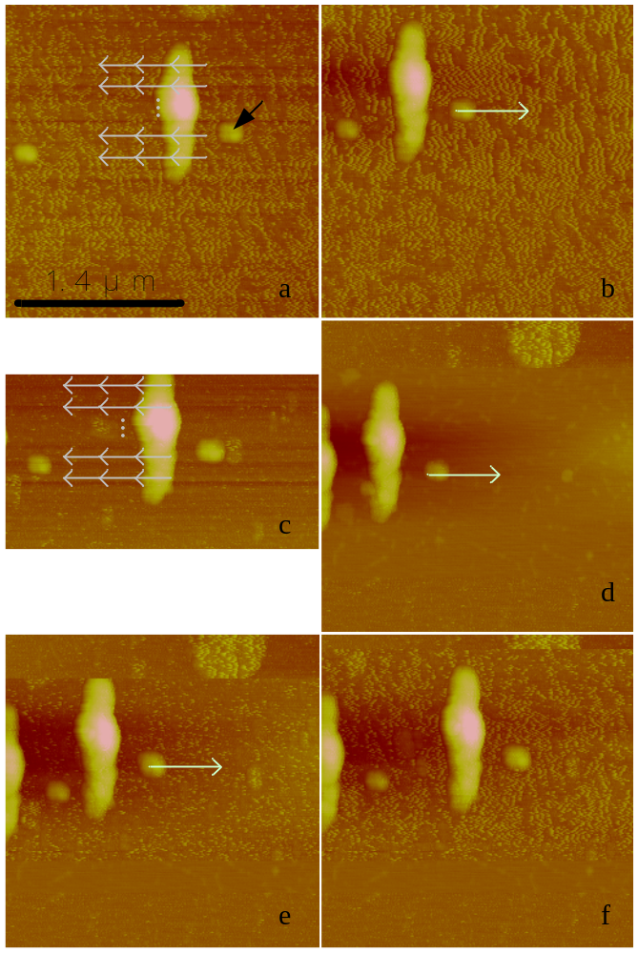Fig. 6. Experimental results of manipulating bovine insulin molecular aggregates: sphere-shaped and rod-shaped. The arrowhead line denotes the AFM tip’s path. The height of the rod-shaped bio-nano-entities is about 70 nm, and the sphere-shaped bio-nano-entities are about 20 nm high.
Acknowledgment
The authors would like to thank our colleague, Ms. Zhikun Zhan, for the help of sample preparation. The authors also would like to thank Ms. Shiyuan Liu of Northeast Yucai School for her suggestion and discussion during the process of this research.
References
- G. Binnig, C. F. Quate, and Ch. Gerber, “Atomic force microscope”, Phys. Rev. Lett., vol 56, Mar, 1986, pp. 930-933.
- H. Hashimoto, M. Sitti, , “Challenges to micro/nanomanipulation using atomic force microscope”, Proceedings of 1999 International Symposium on Micromechatronics and Human Science, 23-26 Nov. 1999, pp. 35-42.
- T. Junno, K. Deppert, L. Montelius, and L. Samuelson, “Controlled manipulation of nanoparticles with an atomic force microscope,” Appl. Phys. Lett., vol. 66, no. 26, June 1995, pp. 3627–3629.
- M. Guthold, M.R. Falvo, W.G. Matthews, S. Paulson, S. Washburn, D. A. Erie, R. Superfine, F. P. Brooks Jr, R. M. II Taylor, “ Controlled manipulation of molecular samples with the nanoManipulator”, IEEE/ASME Transactions on Mechatronics, Vol. 5(2), June 2000, pp. 189 - 198.
- M. Sitti and H. Hashimoto. “Tele-nanorobotics using atomic force microscope”, In Proc. IEEE Int. Conf. Intelligent Robots and Systems, October 1998, pp. 1739-1746.
- G. Li, N. Xi, M. Yu, and W. Fung, “Development of augmented reality system for AFM-based nanomanipulation”, IEEE/ASME Transactions on Mechatronics, Vol. 9(2), June 2004, pp. 358-365.
- Z. Liu, Y. Yang, and Y. Qu, et al, “Vibration-Mode Based Real-Time Nanoimaging and Nanomanipulation”, Proceedings of the 7th IEEE International Conference on Nanotechnology, August 2 - 5, 2007, Hong Kong, pp. 515-519.
- Y. Yang, Z. Dong, Y. Qu, M. Li, and W. Li, , " A programmable AFM-based nanomanipulation method using vibration-mode operation" , Proceedings of 3rd IEEE International Conference on NEMS, 6-9 Jan. 2008, pp. 681 - 685.
- Sitti, M., Hashimoto, H., “Controlled pushing of nanoparticles: modeling and experiments”, IEEE/ASME Transactions on Mechatronics, Vol. 5（2）, June 2000, pp. 199-211.
- Tafazzoli, A., and Sitti, M., “Dynamic modes of nanoparticle motion during nanoprobe-based manipulation”, Proceedings of the 4th IEEE Conference on Nanotechnology, 16-19 Aug. 2004, pp. 35-37.
- H. Chen, N. Xi, and G. Li, “CAD-Guided Automated Nanoassembly Using Atomic Force Microscopy-Based Nanorobotics”, IEEE Transaction On Automation Science And Engineering, VOL. 3, NO. 3, July 2006, pp. 208-217.
- B. Mokaberi, J. Yun, M. Wang, and A. A. G. Requicha, “Automated nanomanipulation with atomic force microscopes”, Proceedings - IEEE International Conference on Robotics and Automation, 2007, pp. 1406-1412.
- J. Hu, Y. Zhang, B. Li, HB Gao, U. Hartmann, and MQ, Li, “Nanomanipulation of single DNA molecules and its applications”, Surface and interface analysis, vol. 36(2), Feb. 2004, pp. 124-126.
- R. W. Carpick, D. F. Ogletree, and M. Salmeron, "Lateral stiffness: A new nanomechanical measurement for the determination of shear strengths with friction force microscopy", Appl. Phys. Lett., Vol. 70(12), March, 1997, pp. 1548-1550.

 *Contact author: wen@mae.cuhk.edu.hk; Wen J. Li is a professor at The Chinese University of Hong Kong and also an affiliated professor at The Shenyang Institute of Automation, CAS. This project is funded by the Chinese National 863 Plan (2006AA04Z320) and NSFC’s Key Project (60635040)

