AA Size Power Cell for Wireless Applications
Using Micro-Fabricated Resonators

Johnny M.H. Lee¹, Steve C.L. Yuen², Mimi H.M. Luk³, Gordon M.H. Chan¹, Thomas K.F. Lei¹,
Wen J. Li^{*,1}, Philip H.W. Leong² and Yeung Yam³
¹Centre for Micro and Nano Systems
²Custom Computer Laboratory
³Intelligent Control Systems Laboratory
The Chinese University of Hong Kong,
Shatin, N.T., Hong Kong SAR
*Contact Author : wen@acae.cuhk.edu.hk

Abstract

This paper presents the preliminary design and experimental results of a standard AA size vibration-induced micro power generator. The energy transduction unit of this micro power generator is a spring mass system that uses MEMS fabricated copper springs to convert mechanical energy into electrical power by Faraday’s Law of Induction. We have shown that this AA size power cell is capable of producing ~2.5V DC and ~60μW with a 100kΩ loading when charged for about one and a half minutes. Potential applications for this micro power generator to serve as a power supply for a wireless temperature sensing system was proved to be possible with input frequencies at about 79Hz with an amplitude of approximately 250microns.

Keywords: micro power generator, micro energy transducer, self-powered sensing

1. INTRODUCTION

Traditional alkaline batteries have being used for almost a century, and have brought dramatic revolutions to human lives. However, shelf life, replacement accessibility and potential hazards of chemicals are some of the problems when chemical batteries are used. Our ongoing work is to develop a brand new power supply with unlimited shelf life and is environmentally safe. Research on micro power generator have been done by various groups throughout the world. Williams and Yates developed an electromagnetic micro generator to produce 0.3μW in 1997 [1], Amirtharajah & Chandra-Kasan used a vibration-based power generator to drive a signal processing circuitry in 1998 [2]. Nevertheless, neither of the groups was able to demonstrate a micro power generator capable of producing enough power to drive an off-the-shelf wireless circuit.

In this paper, we will present our recent results in creating an energy transducer using MEMS compatible SU-8 fabricated copper springs to drive a wireless temperature sensing system. Thus far, we are able to get ~2.4V peak to peak AC from two micro power transducers connected in series and vibrating at 79Hz which is capable to produce ~60μW when connected with a 100kΩ resistor. We have succeeded to package two transducers with a power-management circuit into a housing with total dimension equal to an AA size battery.

2. GENERATOR DESIGN

The prototype micro power generator consists of five main components: 1) inner and outer housing which is used to carry the resonating structure and the power generating system, respectively, 2) a SU-8 fabricated copper resonating spring, 3) a N45 grading rare earth permanent magnet, 4) copper coil, and 5) a power-management circuit for output voltage step up and energy storing purpose. The orientation of inner housing, magnet and the resonating spring is shown in Figure 1a, and the illustrative drawing of the AA size micro power generator is shown in Figure 1b.
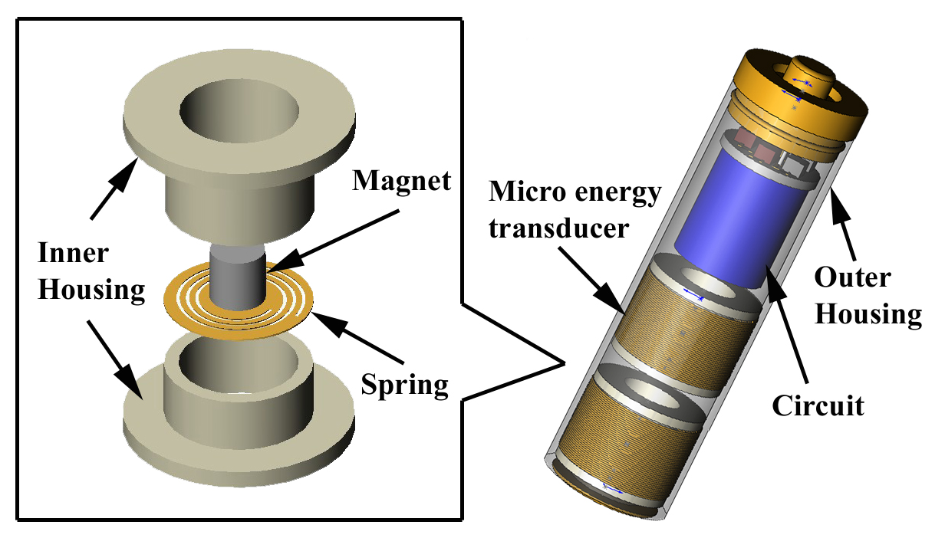
(a) | (b)
Figure 1. Illustrations of: (a) inner structure of the micro power generator; (b) the AA size micro power generator which is integrated with a power-management circuit.
We have shown that when connecting two micro power transducers together in parallel will give a larger current output, whereas larger voltage could be obtained when connected in series. Therefore, we are able to adjust the performance of the AA size micro power generator to accommodate for different purposes. The dimensions and composition of components inside the AA-size “power-conversion cell” is given in Figure 2.
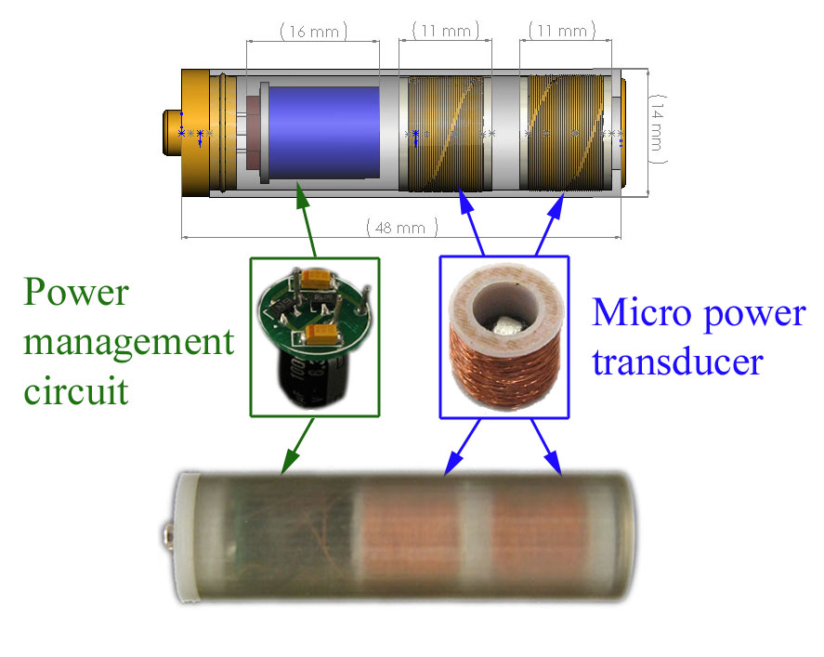
Figure 2. The AA-size micro power generator which consists of two transducers and a power management circuit.

3. DESIGN OF THE RESONATING STRUCTURE

Using ANSYS to simulate the resonating structures, it was found that springs with spiral geometry have lower spring constant and stress concentration than other designs, such that a larger displacement can be obtained [3]. We have used a Q-switch Nd:YAG (1.06μm wavelength) laser to micromachine the spiral resonating spring as shown in Figure3a and b.
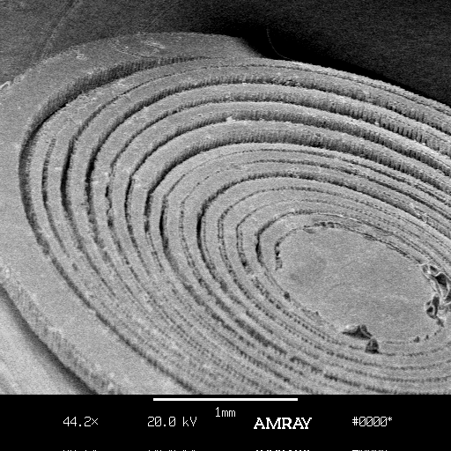 | 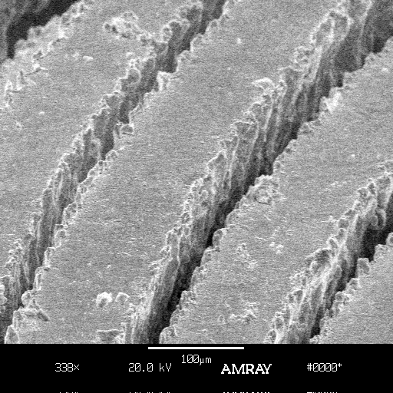
(a) | (b)
Figure 3. SEM pictures of : (a) a laser-micromachined copper spring with diameter of 5mm;. (b) close up of the copper spring; width of the spring is ~100μm.
Using laser-micromachining to fabricate the copper spring is direct, fast, but the cutting resolution is not ideal (see Figure 3b). We have developed another process which involves high-aspect-ratio electroplating of copper using lithographic techniques. The fabrication process is shown in the following section.

4. SU-8 BASED MEMS RESONATOR

Fabrication Process

A SU-8 based electroplating technique was used to fabricate the springs as shown in Figure 4. The fabrication process starts with a polymethylmethacrylate (PMMA) substrate. The Cr/Au (500Å/2000Å) seed layers are deposited on a PMMA substrate by E-beam deposition. SU-8, a negative thick photoresist (PR), is deposited on the PMMA by spin-coating (100-150μm thick). The resist is soft baked in an oven at 40°C for 2 days. After that, the resist is exposed with 400nm UV under a mask with the designed spring patterns for 20 minutes. Following the exposure, the resist is developed in SU-8 developer for 10-15 minutes at room temperature with mild agitation and rinsed with isopropyl alcohol. The above processes create the thick SU-8 mold on a PMMA substrate as shown in Figure 4d. Then, the mold is used to electroplate copper with a current density of 40mA/cm2 for 1.5 hours. A 100μm thick copper spring resonator can be fabricated in the SU-8 mold using the above parameters. Finally, the SU-8 resist and PMMA substrate are separated using the MicroChem Remover, resulting in isolated copper spring resonators as shown in Figure 5.
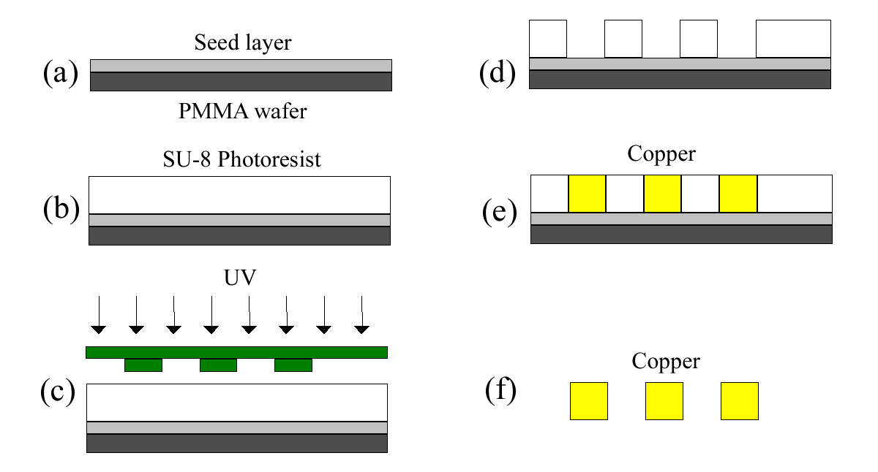
Figure 4. SU-8 based copper resonator fabrication process. (a) Sputter Cr/Au seed layers on PMMA substrate; (b) coat thick SU-8 negative PR and soft bake; (c) expose SU-8 PR with spring pattern mask using UV light source; (d) develop in SU-8 developer; (f) electroplate copper into the SU-8 mold; (g) strip SU-8 and PMMA substrate by MicroChem Remover.
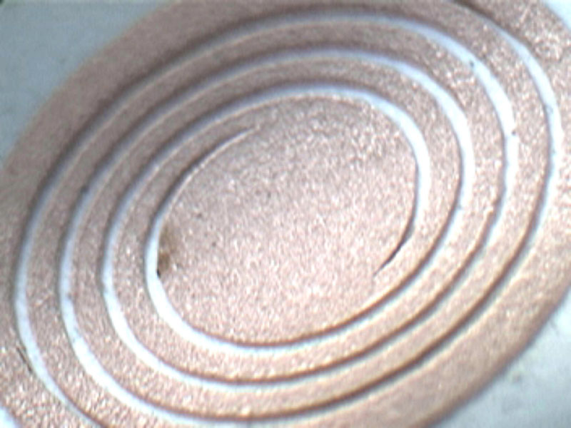 | 
(a) | (b)
Figure 5. (a) An electroplated copper spring with diameter of 8mm. (b) close up of the copper spring.

5. RESONATOR CHARACTERISTICS

Three distinctive modes of resonance were observed when the spring-mass system was under a mechanical input vibration. Sample frames captured from the digital movies are shown in Figure 6 which shows the 3 modes of vibration. The 1st mode is a vertical resonance. For the 2nd and 3rd modes, the mass appeared to cyclically rotate about an axis parallel to the plane of the coil. Most interestingly, the voltage output at the 2nd and 3rd modes of resonance for the generator is higher than the 1st mode resonance. Physically, this can be explained by the fact that Faraday’s Law predicts the voltage output to be proportional to the rate of changing magnetic flux, and hence, faster the movement of the mass, the greater the current induction. It was found that if the a spring can be designed to vibrate in a horizontal plane with rotation, rather than to vibrate in a vertical direction relative to a coil, the voltage output can be increased and the stress on the spring can be reduced.
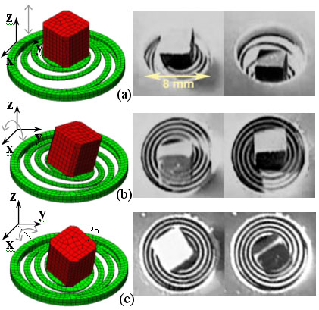
Figure 6. Simulation and experimental results for 3 different resonance vibration modes are matched: (a) 1st mode vibration (vertical); (b) 2nd mode vibration (horizontally along x axis); (c) 3rd mode vibration (horizontally along an axis between x and y axis).
6. EXPERIMENTAL RESULTS

To test the power-conversion cell, a 100k resistor was connected to the capacitor of the power management circuit, and the potential difference across the resistor was measured. At 3rd mode vibration, it takes about one and a half minutes for the capacitor to charge to ~2.5V DC. The peak to peak voltage output of micro power generator at input vibration frequencies from 0-120 Hz was measured and is shown in Figure 8.
The micro power generator tested in this experiment has the largest voltage output when vibrating at 79Hz. The two transducers connected in series vibrate at its resonance frequency and superimpose the voltage generated, resulted in a sharp peak as shown in Figure 8. Measurement of RMS voltage input and output from the power management circuit is shown in Figure 9.
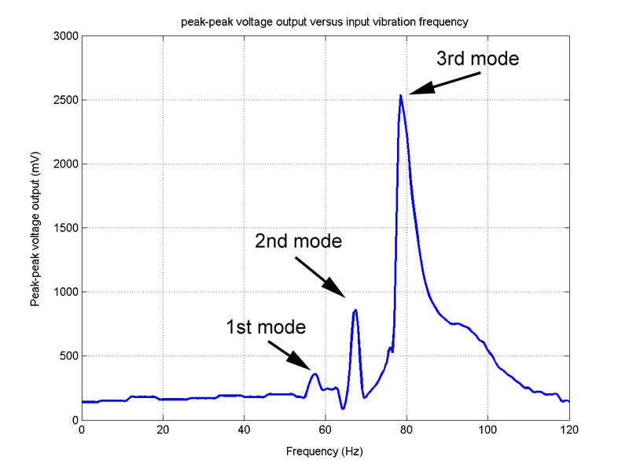
Figure 8. peak to peak voltage output of the micro power generator at different input vibration frequencies.
When the generator is vibrating at 79Hz, the RMS voltage generated by the two transducers are ~840mV, the power management circuit step up the voltage to ~2.46V which is almost three times the input voltage. The power output for the transducer when loaded with a 100kΩ resistor is ~60μW. The power output of the generator at different input vibration frequencies is shown in Figure 10.
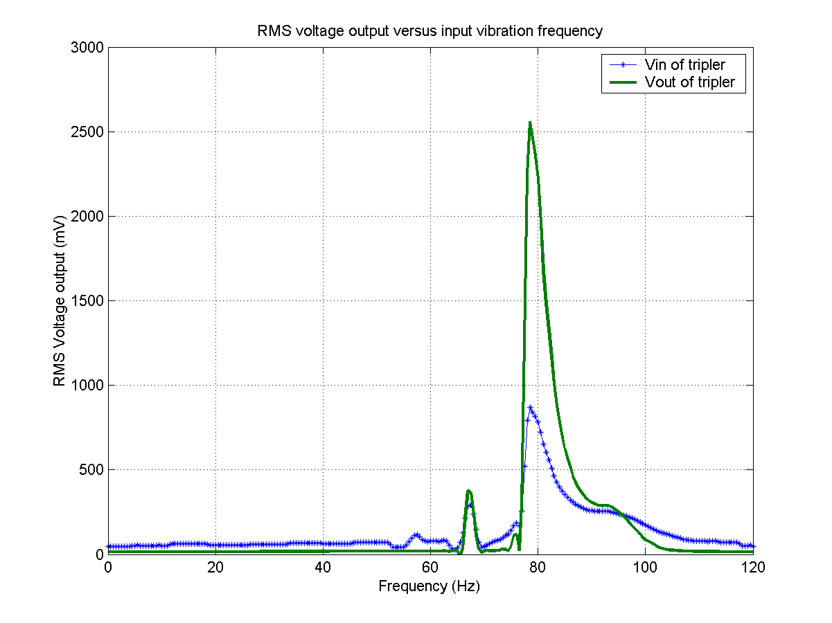
Figure 9. RMS voltage measurement at input and output of the power management circuit at different vibration frequencies.
The results given above were obtained using two transducers connected in series for the cell. The transducers can also be connected in parallel in the case that larger current is desired.
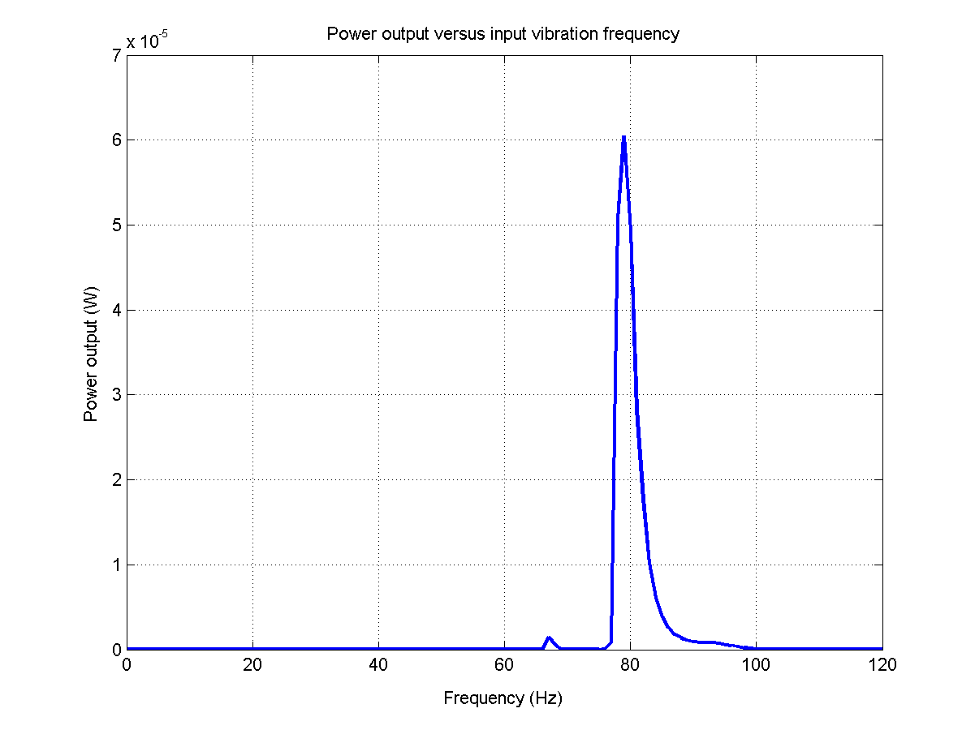
Figure 10. Power output of the micro power generator loaded with a 100kΩ resistor at different input vibration frequencies.

7. APPLICATIONS

RF wireless thermometer

A wireless thermometer system was implemented to demonstrate an application of the micro power generator. The system block diagram is shown in Figure 11. The system has three main components: the micro power generator, startup circuit and application circuit. The micro power generator contains a voltage multiplier, i.e. tripler, which is used to step up the input voltage to >0.9V DC. The tripler is a passive circuit which can operate at voltages lower than a normal MOS transistor’s threshold voltage. It also charges up the reserver capacitor Cres. The startup circuit only applies power to the application circuit when the voltage at the output of the tripler exceeds a fixed threshold, Vth(H). It will bridge off the system ground rail from power ground when voltage at the output of the tripler drops below a low threshold, Vth(L). A charge pump regulator further steps up the output of tripler to 3.0V. To save power, the microprocessor controls the power supplies for peripheral chips and only applies power via its programmable I/O pins when required. Host-received data latency was designed and verified as ~1.4 seconds. The system took ~80 seconds for first activation and consecutive measurements were made with a period of ~25 seconds.
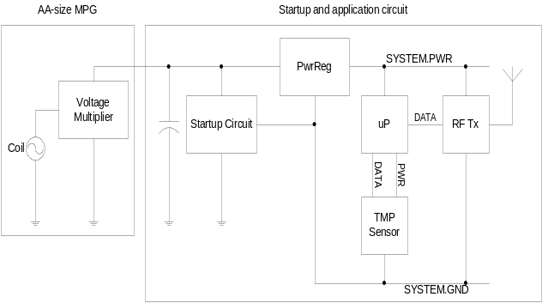
Figure 11. System block diagram for the RF wireless thermometer
8. SUMMARY

Thus far, we have shown that an AA size magnetic-induction based micro power generator is capable of converting mechanical vibrations into electrical power sufficient to drive a RF wireless circuit. Typical input mechanical amplitude needed is ~250μm at 79Hz to allow the transducer to generate enough power for wireless data transmission over ~15m. The main component of this power cell is an energy transducer made using MEMS compatible high-aspect-ratio SU-8 process. Efforts are underway to find specialized wireless applications for this AA-size power conversion cell.

9. ACKNOWLEDGMENT

This work was funded by the Hong Kong Research Grants Council (Grant No. CUHK 4416/99E), and is currently supported by a grant from the Hong Kong Innovation and Technology Commission (ITF/185/01). We also appreciate Magtech Industrial Company (Hong Kong) for donating and fabricating the magnets needed for this project. In addition, Cyberjet Technology (HK) Limited has provided invaluable assistance in developing the SU-8 molding technology used in this project.

REFERENCES

[1] C. B. Williams, and R. B. Yates, “Analysis of a micro-electric generator for microsystems”, Sensors and Actuators, A 52, 1996, pp. 8-11.
[2] R. Amirtharajah, and A.P. Chandrakasan, “Self-powered signal processing using vibration-based power generator”, IEEE J. of Solid-State Circuits, vol. 33, May 1998, pp. 687-695.
[3] W. J. Li, G. M. H. Chan, N. N. H. Ching, P. H. W. Leong, and H. Y. Wong, “Dynamical modeling and simulation of a laser-micromachined vibration-based micro power generator”, International Journal of Non-linear Sciences and Simulation, vol. 1, 2000, pp. 345-353.

